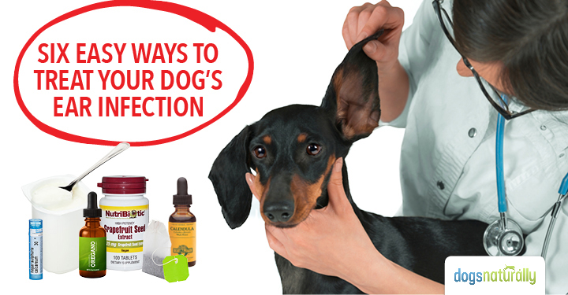
Does your dog have itchy, gunky, smelly or even painful ears that just don’t seem to get better?
If you answered yes, you’re not alone. And like other dog owners, you’re probably frustrated by how hard it can be to get rid of chronic ear issues once and for all.
Ear problems are one of the biggest reasons dogs visit the vet, and they can be really hard to resolve.
An ear infection is rarely “just an ear infection.”
Like other skin conditions, ear problems are often a symptom of underlying disease. This means you’ll need to look a lot deeper than the ears to help your dog overcome her problems.
We asked homeopathic veterinarian Michael Dym DVM to give us his advice on ear health for dogs.
First, Dr Dym emphasized the difference between holistic and conventional approaches to ear care.

Holistic View Of Ear Issues
The first step in holistic treatment for your dog’s ear issues is to identify the possible sources of the problem.
Many dogs today have been inundated with too many vaccinations, drugs, pesticides and other chemicals, and the body tries to get rid of them through the bowels, the urinary tract and through the skin and the ears.
Discharge and inflammation in the ears are often a sign that the body’s trying to eliminate toxins.
From a holistic perspective, this is a good thing! Your dog’s body is working to heal itself by getting rid of toxic substances.
The goal of holistic treatment is to avoid interfering with this natural detoxification process.
Unfortunately conventional medicine takes a completely different approach.

Why Conventional Treatments Don’t Work
If your dog’s been treated for ear infections by a conventional vet, she’s probably been given topical treatments and antibiotics.
These treatments may help the ears clear up at first, but the problem often comes back again later. That’s because the drugs just suppress the symptoms (your dog’s gunky, itchy ears) without addressing the underlying condition that’s causing the symptoms.
And when antibiotics stop helping, your vet may even prescribe steroids … drugs that suppress symptoms and can have many harmful side effects.
The holistic view is that these suppressive treatments drive the symptoms deeper, which can ultimately make your dog sicker over time.

Causes Of Ear Issues
In Dr Dym’s practice he’s observed a few different reasons dogs get ear infections.

Diet
Diet is a huge factor, especially when dogs are on kibble diets, which are very high in refined carbohydrates and contribute to yeast and food allergies or intolerances that can cause inflammation in the ears.

Anatomical
Dogs with long ear flaps (like Cocker Spaniels) often have a tendency for waxy buildup and discharge. The ear canal is a dark moist environment that can encourage the growth of yeast and bacteria.

Lifestyle
Dogs who love to swim may get water in their ears that can lead to ear issues. Others who are out in the woods a lot can get foreign bodies like foxtails or seeds in their ears, causing irritation.
Dr Dym recommends feeding your dog a whole foods, raw meat diet, minimizing vaccines and other pharmaceutical drugs, and avoiding pesticides and other chemicals in your dog’s environment.

DNM Academy Member Extra
Access the ‘Raw Feeding Basics’ Course in Dogs Naturally Academy
Get the step-by step guide to introducing a raw diet to your dog.
Click here to access this Course
Not an Academy member? Click here to learn more about DNM Academy
Dogs who are raised like this are less likely to develop reactions that lead to itching, discharge and inflammation in their ears.
But if your dog does get itchy, gunky ears, what can you do?

Soothing Solutions
First of all, don’t clean your dog’s ears unless wax and discharge are causing her discomfort.
Healthy ears don’t need cleaning so just leave them alone!
If your dog’s showing signs of discomfort like head shaking, pawing or rubbing her ears, here are some of Dr Dym’s favorite natural solutions to soothe the irritation.

Green Tea
Boil 8 oz of water and add two green tea bags. Let the tea steep for a few minutes and cool to lukewarm temperature. Sponge or syringe some of the solution into the ear canal.

Calendula Tincture
Buy herbal calendula in tincture form. Add 5 to 10 drops of calendula tincture to ½ to 1 cup of lukewarm filtered water and sponge or place with a dropper into the ears.

Yogurt
Plain yogurt can be placed in the ear canal with a syringe to help repopulate the ear with “good” bacteria.

Zymox Enzymatic
Zymox Enzymatic can be helpful in breaking down the discharge and wax and soothing irritation. (Note: make sure you buy the Zymox Enzymatic solution and not the one with hydrocortisone).

Grapefruit Seed Extract
Grapefruit seed extract (GSE) is a powerful natural antioxidant that’s antibacterial, antiviral and antifungal. It can be used topically as well as internally.
To use topically, mix 10 drops of GSE with ½ oz of pure aloe vera juice and use it to clean the ears when needed. Internally, add 3 to 5 drops of GSE to your dog’s food.

Oil Of Oregano
Oil of oregano is naturally antibacterial. Add one drop to ½ oz of warm pure aloe vera juice. You can use this mixture topically in the ear as well as adding a few drops to your dog’s food.
These are all gentle solutions that can help keep your dog comfortable.
Dr Dym reminded us that none of these things alone will make your dog’s ear problems go away, but they will help soothe the irritation while your holistic vet addresses what’s causing your dog’s ear issues at a deeper level.
(NOTE: Still not sure about raw? Click here to see what a raw diet is all about and start treating ear infections from the inside out!)

Homeopathic Care
If your dog has chronic, recurring ear issues, it’s best to get help from a homeopathic vet who can do a complete analysis of your dog’s overall symptoms. Your homeopath can then prescribe a constitutional remedy to address the underlying cause of your dog’s ear problems.
You can find a homeopathic vet at theavh.org or pivh.org. Most will do phone consults so they don’t have to be local.
Be aware that sometimes, when your dog’s treated with constitutional homeopathy, skin and ear issues can temporarily get worse. Healing comes from the inside out, so ear issues are often the last to go away, after the deeper issues improve.
For acute flare-ups (not chronic issues), Dr Dym suggests some helpful homeopathic remedies.
Use the one that most closely matches your dog’s symptoms, in 30C potency.

Belladonna
Use Belladonna when the ears are very hot and inflamed. Your dog may be impatient and irritable.

Pulsatilla
This remedy is helpful for acute flare-ups with sensitivity and redness, along with a yellowish discharge. Pulsatilla animals like to sit near open windows, hate getting their paws wet and won’t go out in the rain. They also tend to have a very sweet (and slightly needy) disposition.

Hepar Sulphuris
Hepar sulph is useful for irritable animals who don’t like to have their inflamed ears touched.

Silica
Use Silica if your dog has a foxtail or other foreign object in her ear. Silica can help eject the foreign object.

Dosing
Tip 2 or 3 pellets straight into your dog’s mouth, or stir the pellets into a little filtered water and then use a dropper to place some of the liquid on your dog’s gums.
Give the remedy once then wait to see if there are any changes.
If the condition improves, do nothing.
If you see an improvement followed by a decline, redose.
If you see no change, consider trying another remedy.

Patience With Chronic Conditions
Dr Dym emphasizes the need for patience with the healing process when you’re dealing with chronic ear issues.
As your dog discharges toxins to the outside through her ears, remember that this is an important part of healing. It’s how your dog’s life force “lets off steam” and you don’t want to suppress that process by using anything that will magically make the symptoms disappear.
Any drug or herb that can remove symptoms quickly is likely to suppress them and drive them deeper into the body where they can cause more serious issues later.
So, be patient, and keep your dog comfortable with the soothing solutions while your homeopathic vet addresses your dog’s overall constitutional health.

